 CONTROLS WITHIN THE WEBINAR
 WAITING FOR THE HOST TO START THIS WEBINAR
 JOINING THE WEBINAR
MENU – CLICK OPTIONS BELOW

JOINING THE WEBINAR
Join by Link
To join the webinar, click the link that the host provided you or that you received in your email when you registered.
Manually Join the Webinar
If clicking the link does not open the webinar, you can also manually download the Zoom application from the Download Center. The first option, Zoom Client for Meetings, is the same application needed for webinars.
- Download Zoom Client for Meetings from the Download Center.
- Install the application.
- Open the Zoom application.
- Click Join a Meeting.
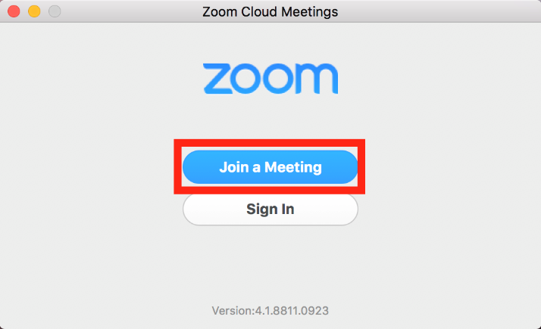
- Locate the 9-digit meeting ID/webinar ID from your registration email. It may appear at the end of the phone dial-in information, or it will be in the join link, just after https://zoom.us/w/
- Enter the 9-digit meeting ID/webinar ID into the Meeting ID/Personal Link Name field.
- Click Join.
- Enter your name and email address if requested. Click Join Webinar.

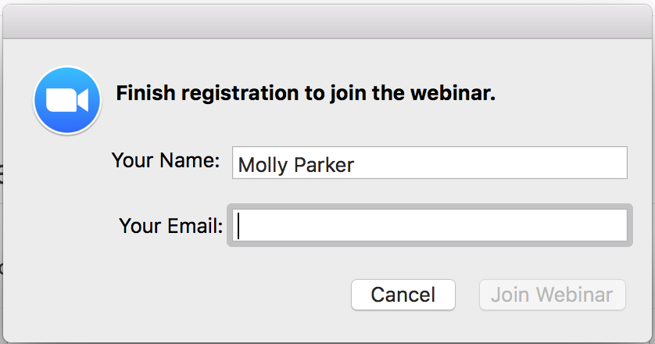
- This should take you into the webinar if the webinar is in session.
WAITING FOR THE HOST TO START THIS WEBINAR
If you receive a message that you are waiting for the host to start this webinar, it means that the host has not started broadcasting the webinar yet. They either have not started it or are in the practice session, preparing to take the webinar live. You have connected to Zoom and the webinar will start as soon as the host starts broadcasting.
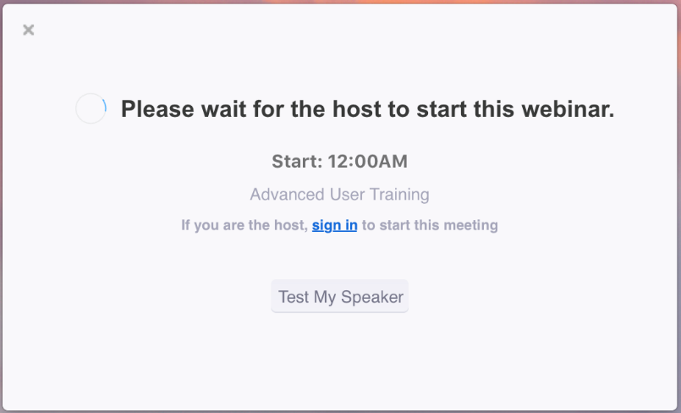
You may also receive a message noting the date and time of the webinar. If you receive this message, please check the date and start time of the webinar, including the timezone. You will see this message if the webinar is scheduled for another day.
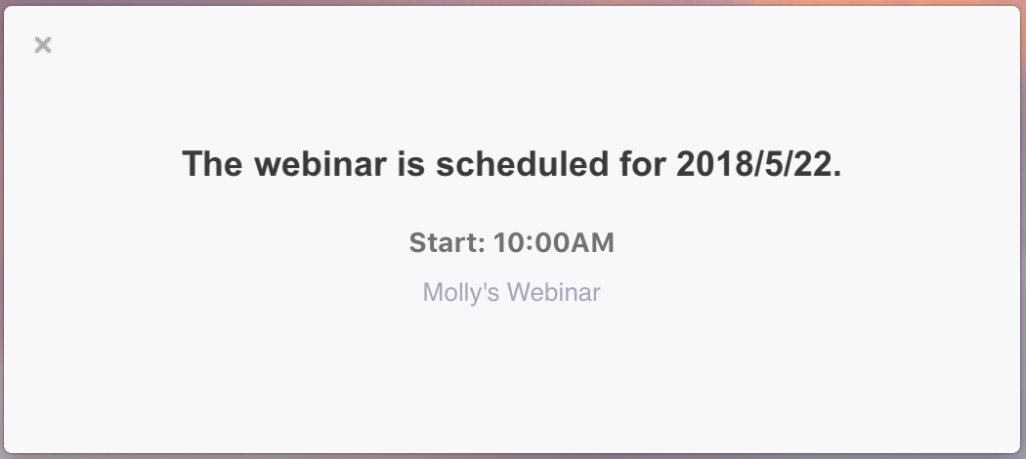
CONTROLS WITHIN THE WEBINAR
Audio Settings
- To adjust your audio settings in the webinar, click on Audio Options.
- This will open up the audio settings section of your Zoom application settings.
- You can click on the drop downs to change the audio devices or adjust the sliders to change the volume.

- You can also click on the ^ next to Audio Settings to change your speaker.
Chat
The in-meeting chat allows you to send chat messages to and send a message to the host, panelists, and attendees (if permitted).
- Click Chat to open the in-meeting chat.
- The chat will appear on the right side of your Zoom window if you are not in full screen. If you are in full screen, it will appear in a window that you can move around your screen as needed.
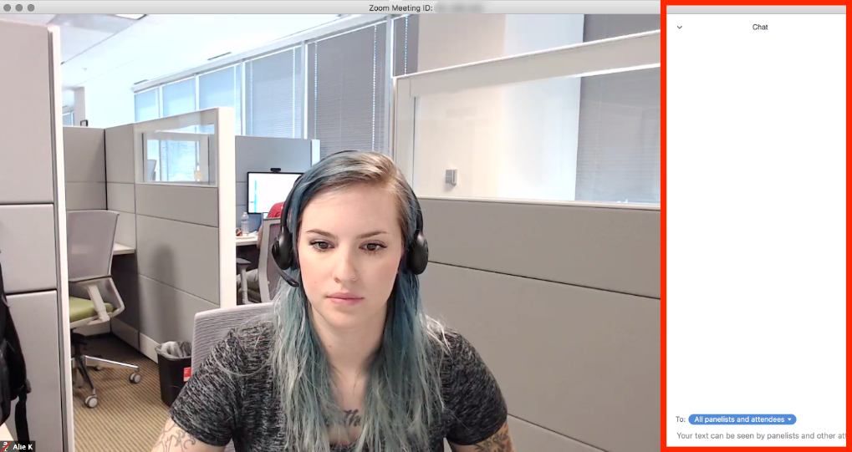
- To change who you are chatting with, click the drop down beside To:.
- Type your message and press Enter.
Raise Hand
You can raise your hand in the webinar to indicate that you need something from the host. The host may instruct you on how they plan to use this. Many webinar hosts use this feature to know if an attendee has a question and would like to speak out loud. Read more about raising your hand.
- Click Raise Hand in the attendee controls.
- Your hand will stay raised until you or the host lower it. You can lower your hand if needed by clicking Lower Hand.
Leave meeting
Click Leave meeting to leave the webinar at any time. If you leave, you can rejoin if the webinar is still in progress, as long as the host has not locked the webinar.

